CSE1002

Assignment 6

Knapsack Problems

1. 0 1 knapsack
2. fractional knapsack Problems

**20BDS0405 (Bimal parajuli)**

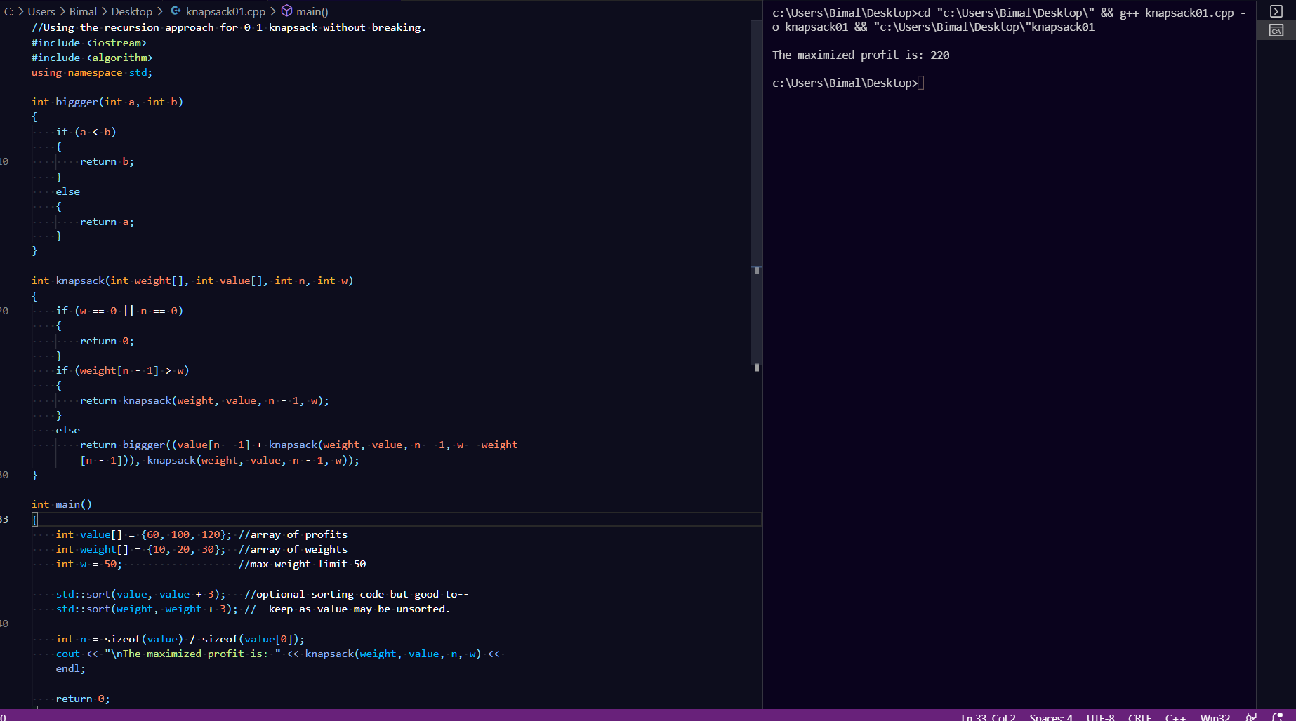0 1 knapsack problem where division of material is not allowed.

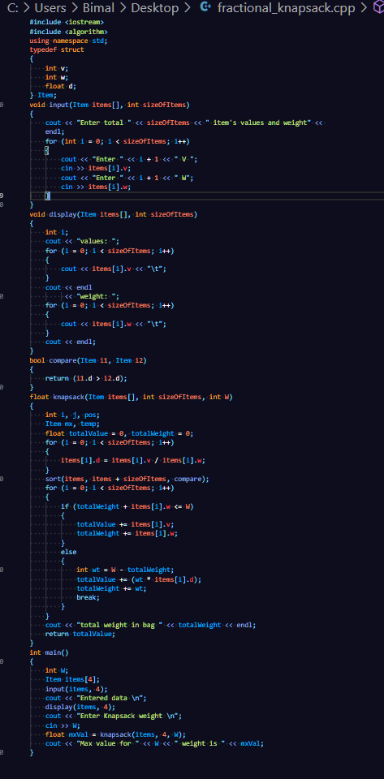**Fractional knapsack** problem where division of material is allowed:

